**3.** **ReactJS – HOL**

**React Application : scorecalculatorapp:**

1. Create a React project named “scorecalculatorapp” type the following command in terminal of Visual studio:



1. Create a new folder under Src folder with the name “Components”. Add a new file named “CalculateScore.js”
2. Type the following code in CalculateScore.js

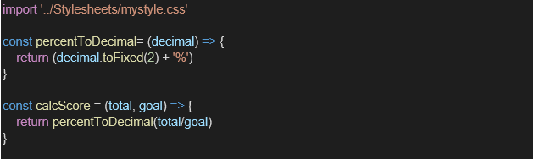

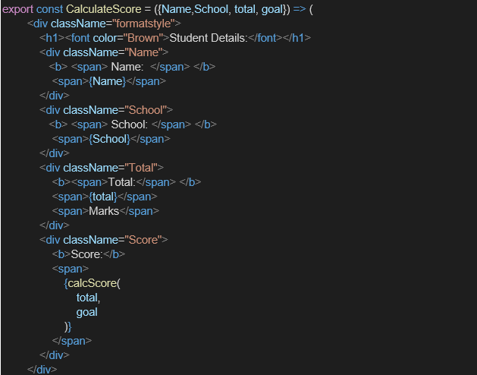

1. Create a Folder named Stylesheets and add a file named “mystyle.css” in order to add some styles to the components:

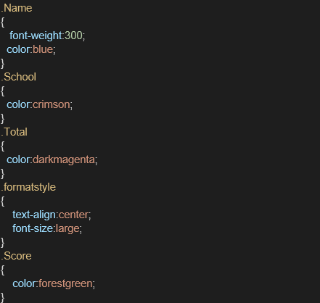

1. Edit the App.js to invoke the CalculateScore functional component as follows:

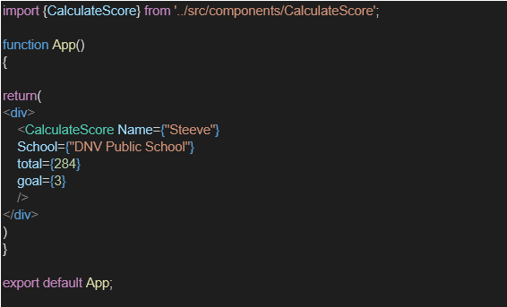

1. In command Prompt, navigate into scorecalculatorapp and execute the code by typing the following command:



1. Open browser and type “localhost:3000” in the address bar:

**Final Ouput:**

